# Lab: Policy Based Management

* (**Task1**) Show in a screenshot like above that **usp_MyPolicyTest** stored procedure is created in **MyPolTestDB** successfully. Do your own work and do not copy the screenshot above.

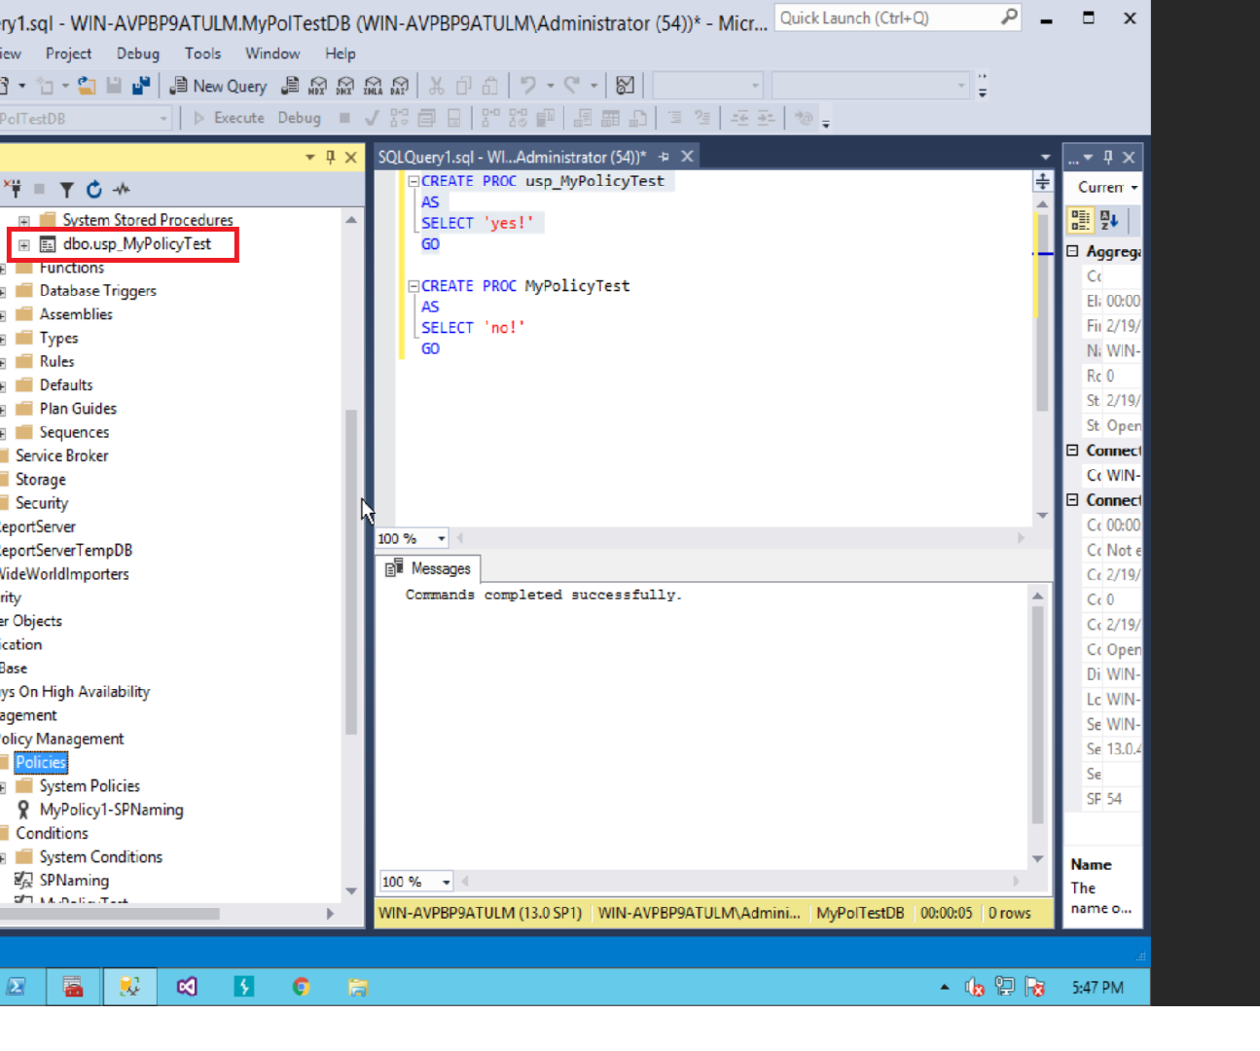

* (**Task2**) Show in a screenshot that **MyPolicyTest** stored procedure cannot be created. Capture the screen showing an error message.

